CHP@orr.gov.uk

Consumer team
Office of Rail and Road
25 Cabot Square
London
E14 4QZ
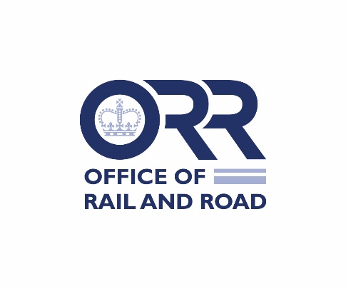
Response letter

Modification of London Underground Ltd’s Complaints Handling and Alternative Dispute Resolution obligations
On 20 October 2022, the Office of Rail and Road (“ORR”) issued statutory consultations on proposals to modify the station and passenger licences of London Underground Ltd in respect of its obligations regarding Complaints Handling and Alternative Dispute Resolution (“the Consultations”).
For each licence held, please use a separate form to respond and provide your consent, representations or objections to the respective complaints handling modifications. This form should be returned to ORR using the contact details above by 5pm 21 November 2022.
Please indicate your responses by placing a (tick) mark in the yes or no boxes overleaf:

Licence number

Please insert here the number of the licence for which you are responding:

Complaints Handling Obligation | Yes | No
I confirm that London Underground Ltd consents to ORR’s proposed modifications to Complaints Handling obligations, as set out in Annex A1 of the Consultations | ☐ | ☐
Alternative Dispute Resolution Obligation | Yes | No
I confirm that London Underground Ltd consents to ORR’s proposed modifications to Alternative Dispute Resolution obligations as set out in Annex B1(i) of the Consultations OR | ☐ | ☐
OR [where consent is not provided to the modifications set out in Annex A1] I confirm that London Underground Ltd consents to ORR’s proposed modifications to Alternative Dispute Resolution obligations as set out in Annex B1(ii) of the Consultations AND | ☐ | ☐
I confirm that London Underground Ltd consents to ORR’s proposed modifications to Alternative Dispute Resolution obligations as set out in Annex B1(iii) of the Consultations | ☐ | ☐
If you have any objections or representations, please state them here:

Name …………………………………………………

Position …………………………………………………

Date …………………………………………………

For the licence holder
Please return this form to ORR using the contact details above, preferably using email to CHP@orr.gov.uk by 5pm on 21 November 2022.

