CHP@orr.gov.uk

Consumer team
Office of Rail and Road
25 Cabot Square
London
E14 4QZ
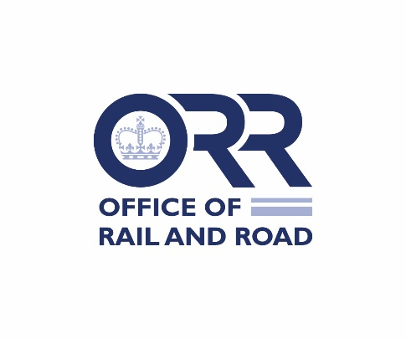
Response letter

Modification of licence holders’ Complaints Handling and Alternative Dispute Resolution obligations
On 20 October 2022, the Office of Rail and Road (“ORR”) issued statutory consultations on proposals to modify licences and Statements of National Regulatory Provisions in respect of their obligations regarding Complaints Handling and Alternative Dispute Resolution (the “Consultations”).
For each licence held, please use a separate form to respond and provide your consent, representations or objections to the respective complaints handling modifications. This form should be returned to ORR using the contact details above by 5pm 21 November 2022.
Please indicate your responses by placing a (tick) mark in the yes or no boxes overleaf (Licence holders to use Table 1 only; SNRP holders to use Table 2 only).

Licence number

Please insert here the number of the licence for which you are responding:

Table 1: Consent from Railways Act Licence Holders only
Complaints Handling Obligation  (only complete if Railways Act Licence is held) | Yes |  | No
I confirm that the licence holder consents to ORR’s proposed modifications to Complaints Handling obligations, as set out in Annex A1 of the Consultations | ☐ |  | ☐
Alternative Dispute Resolution Obligation Railways Act Licence (only complete if Railways Act Licence is held) |  | Yes |  | No
I confirm that the licence holder consents to ORR’s proposed modifications to Alternative Dispute Resolution obligations as set out in Annex B1(i) of the Consultations |  | ☐ |  | ☐
OR [where consent is not provided to the modifications set out in Annex A1] I confirm that licence holder consents to ORR’s proposed modifications to Alternative Dispute Resolution obligations as set out in Annex B1(ii) of the Consultations |  | ☐ |  | ☐
Table 2: Consent from SNRP holders only
Complaints Handling Obligation  (only complete if SNRP is held) | Yes | No
I confirm that the licence holder consents to ORR’s proposed modifications to Complaints Handling obligations, as set out in Annex A2 of the Consultations | ☐ | ☐
Alternative Dispute Resolution Obligation Passenger SNRP  (only complete if SNRP is held) | Yes | No
I confirm that the licence holder consents to ORR’s proposed modifications to Alternative Dispute Resolution obligations as set out in Annex B2(i) of the Consultations | ☐ | ☐
OR [where consent is not provided to the modifications set out in Annex A2] I confirm that licence holder consents to ORR’s proposed modifications to Alternative Dispute Resolution obligations as set out in Annex B2(ii) of the Consultations | ☐ | ☐

If you have any objections or representations, please state them here:

Name of licence / SNRP holder …………………………………………………

Name …………………………………………………

Position …………………………………………………

Date …………………………………………………

For the licence holder

Please return this form to ORR using the contact details above, preferably using email to CHP@orr.gov.uk by 5pm on 21 November 2022.

