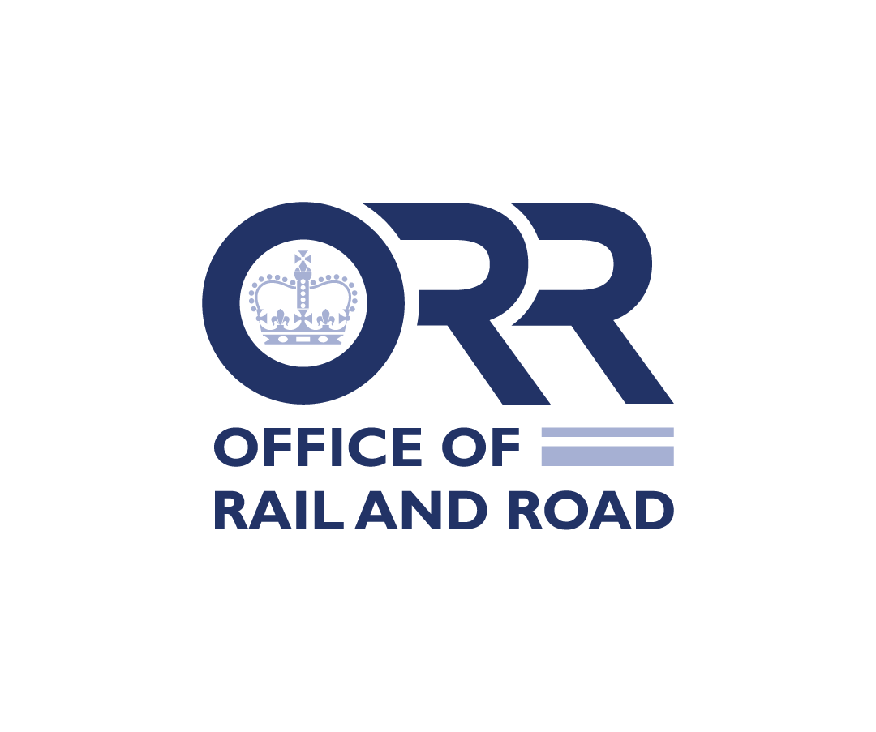
Licence exemption application form
Before completing this form, you should read licensing guidance and the guidance notes in this application form.
- Post/hand deliver a signed copy of this form, with supporting information, to:
Licensing Team, Office of Rail and Road, 25 Cabot Square, London, E14 4QZ. Or email a copy to licensing.enquiries@orr.gov.uk.
- Indicate any information that is commercially sensitive and which you do not want disclosed to third parties.
- There is no application fee.
1. Day to day contact for this application
1.1 Name
1.2 Position/Job title
1.3 Address
1.4 Telephone
1.5 E-mail
1.6 Name, e-mail and phone of alternative contact

2. Company information
2.1 Registered company name
2.2 Company registration no.
2.3 Trading name(s)
2.4 Date and place of incorporation (Guidance note):

2.5 Address of registered office (Guidance note)

2.6 Telephone
2.7 Website address

3. Your planned operations
3.1 What railway asset or class of railway asset operations do you want the exemption to cover? Tick the relevant boxes. See Guidance note.
☐ Network ☐ Light maintenance depot
☐ Passenger train ☐ Station
☐ Non-passenger train
or
☐ All types of asset
3.2 Please describe your planned operations. Attach any maps, diagrams etc that help explain your plans: (Guidance note)

3.3 When do you plan to start these operations? (Guidance note)

3.4 Do you plan to expand your operations later on (e.g. acquire new assets)? (Guidance note)
YES / NO
If yes, please outline your plans.

3.5 What other licences and licence exemptions do you hold or have you applied for? (Guidance note)

4. Safety competence
4.1 Will your planned operations covered by this application require a safety certificate/authorisation under the Railways and Other Guided Transport Systems (Safety) Regulations 2006 (ROGS)? (Guidance note)
☐ Yes. Go to 4.2
☐ No. Go to 4.3
4.2. Have you been granted the ROGS certificate/authorisation that you need for your planned operations? Tick the relevant box:
☐ Yes.
☐ No.
Go to 4.4
4.3 Will you operate vehicles within mainline possessions?
☐ No
☐ Yes
If Yes, do you have the necessary authorisation from Network Rail?
☐ Yes (please enclose copy)
☐ No.
Go to 4.4
4.4 Who is your main contact regarding railway safety at ORR?

5. Declaration
I apply for an exemption from the requirement to be licensed to operate railway assets as specified in Section 3 above. I am aware that it is an offence to make a statement that I know is false in a material particular, or recklessly to make a statement which is false in a material particular.
I declare that, to the best of my knowledge and belief, the statements given in this application are true and complete (Guidance note).
Signed:
Name:
Position of signatory:
(Director or authorised person)
Date:

How to complete the application form
- You can send us the application in a word-processed form if you wish. You must, however, follow the wording of the application form. We will acknowledge receipt. (Return to top.)
- You should be able to expand rows as required. If you have any problems filling out the form, contact licensing.enquiries@orr.gov.uk.
- If supporting information is missing, we will write to you outlining what information we need. If this happens our usual 8-week timescale will restart. Our timescales assume you have made significant progress towards acquiring the relevant safety clearances from Railway Safety (where needed).
- Only apply when you are relatively close to starting operations. We ask that you do not apply speculatively or too far in advance. We welcome informal discussions at any time.

Section 1: Details of day-to-day contact (Return to Section 1)
- Give details of the person ORR should contact with any queries.

Section 2: Company information (Click to return to Section 2)
- State the registered office address. But we will write to the address given for the day-to-day contact, unless specifically asked otherwise.

Section 3: Nature of proposed operation (Click to return to Section 3)
Section 3.2: Description of activity or services to be operated:
- If you want all types of asset, tick that box only, you don’t need to tick the other boxes.
- A full description should be given of the geographical location, scope and extent of the activity proposed under the licence exemption. Please provide any maps that may help to clarify the proposals. Please list the full names of any stations and depots to which the application relates. (Click to return to Section 3.2).
- If it helps describe your operations you may attach your safe systems of working documentation.
Section 3.3: When do you plan to start these operations?
- Please insert a date, not ‘a.s.a.p.’. Also, remember that the application process normally takes around 8 weeks (including a statutory consultation period of at least 28 days), assuming that a complete application is received and the application is straightforward. (Click here to return to Section 3.3). The timescale could be longer, for example, if additional information is needed.
Section 3.4: Do you plan to extend your operations later?
- If YES, please provide details. See our guidance on licence exemptions about scope of exemptions.
- Please be aware that we may disclose all or part of your plans in the public consultation stage. Please mark any commercially sensitive information as such, and we will discuss this with you separately.
Section 3.5: What other licences and exemptions do you hold or have you applied for?
- Please give details of other licences and exemptions held and the date they were granted. Please also give details of any other application made, including any that were refused or withdrawn, or are currently being progressed by ORR. (Click to return to Section 3.5)

Section 4: Safety competence
- Any information you give us will be cross-checked with our colleagues in Railway Safety.
- Giving this information in this form does not satisfy any requirement to give information to Railway Safety under health and safety rules, or to liaise with them, or comply with any direction Railway Safety issues to you.
Section 4.1 and 4.4: (Click here to return to Section 4.)
- For guidance on ROGS please see
http://www.rail-reg.gov.uk/server/show/nav.1511.

Section 4.4
- Please see Guidance on Regulation and certification, at
http://www.rail-reg.gov.uk/server/show/nav.1510
Section 5: Declaration
- Also, please tell us immediately of any material changes to the information you have provided in the application as your application progresses (Click to return to Section 5).
- It is an offence under section 146 of the Railways Act 1993 to make a statement that you know is false in a material particular, or recklessly to make a statement which is false in a material particular.

