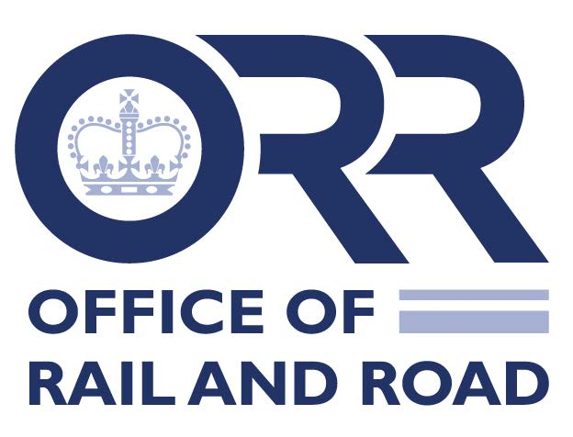
Requesting a meeting with the Office of Rail and Road

The Office of Rail and Road (ORR) welcomes the opportunity to share expertise with countries throughout the international community, where resources allow and within the boundaries of our remit. As a publicly funded body, we prioritise national organisations with similar functions to our own and official delegations on programmes organised with UK Government.

To help us answer your request, please complete this pro-forma as fully as possible. We recommend that before doing so you look at the ORR website at: https://www.orr.gov.uk/about/how-we-work/strategy-duties/our-functions to ensure that the proposed subjects fall within the organisation’s remit.

Please note that the ORR generally requests 6 weeks’ notice from the date of receipt of the pro-forma for the visit to be arranged.

Name of visiting organisation:

Organisation (Please choose the relevant box below)

National Government Regional or local government

Private organisation Academic

Individual Other Government body e.g. regulator

Country of origin:

Proposed date(s) of visit:
(Please propose at least 2 options)

Lead contact:

Email address:

Telephone number:

- What policy areas would you like to discuss? (Please choose from the boxes below)
Railway safety Economic regulation

Consumer protection Monitor Highways England

Channel Tunnel Railway planning & performance
Other (state) ____________________________________________________

- What would you like to get from your visit to ORR?

- Have you been in touch with your Embassy in London or the UK Embassy or High Commission in your country of origin before contacting ORR (If so, please provide contact details)?

- Are you visiting other transport-related organisations while in the UK? (If so, please specify)

- Visitors’ information (Please note we advise a maximum of 5 people)
 | Title (e.g. Mr, Mrs, Ms) | Forename | Surname | Position and role in organisation
Leader of delegation
1
2
3
4
5

- Other information (Do you have any specific dietary, accessibility, translation, cultural requirements? If so, please specify)

- How did you hear about ORR and its work?

Please send completed forms to the ORR Stakeholder team.

Due to resource constraints, the ORR cannot always guarantee facilitating the visit. However, depending on the availability of staff involved, we will do our best to accommodate requests.

In addition, please be aware that while the ORR can receive gifts, that they will have to be declared.

