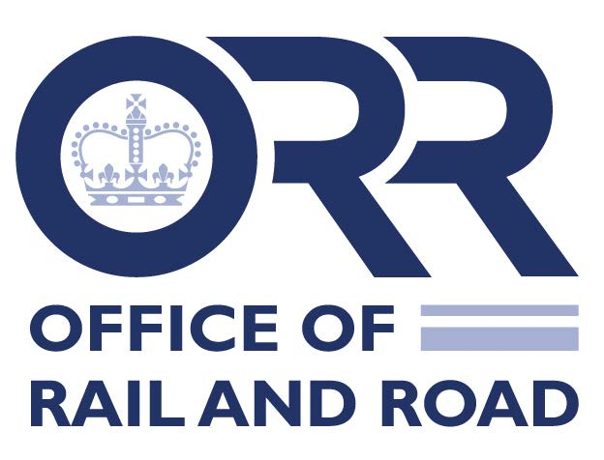

New starter information
Please enter details in block capital letters. This information will be used to verify data held on you is up to date and accurate, and means that you give your consent for it to be stored and processed on the Office of Rail and Road (O R R ) HR and Finance databases as required by the General Data Protection Regulation (GDPR) and Data Protection Act 2018.
Please note that data collected from all sections of this form will be stored by HR in accordance with its privacy notice.

Section A: Personal Details
Enter details below (block letters)
Job Title
Title
First Name
Middle Name
Last Name
Preferred First Name
Date of Birth
National Insurance Number

Section B: Address and Contact Details
Enter details below (block letters)
Address
Postcode
Home Telephone
Mobile Telephone
E-Mail Address

Section C: Additional Information
 | Select appropriate response or enter details below
Gender | Male/Female
Marital Status | Single/Married/Civil Partnership/Divorced/Partnered/prefer not to say
Gender reassignment | Not applicable/transsexual/undergoing gender reassignment
Sexual orientation | Bisexual/gay/heterosexual/lesbian/other/prefer not to say
Belief
Ethnic origin
Nationality
Disability / Special Needs | Yes/no/prefer not to say
If yes please provide details

Section D: Bank/Building Society Details
Enter details below (block letters)
Account Name
(e.g. Miss A. Other)
Account Type
Account No. (8 Digits) or Building Society Roll No.
Sort Code (6 Digits)
Bank/Building Society Name

Section E: Expenses
Please choose from the following options, and place a ‘✓’ in the box next to the appropriate one:
✓
- I confirm that any expenses claimed should be paid into the bank/building society account listed in Section D of the New Starter form.
Or
✓
- I would like any expenses claimed paid into a different bank/building society account to the account detailed in Section D of the New Starter form, and give details below:

Enter details below (block letters)
Account Name
(e.g. Miss A. Other)
Account Type
Account No. (8 Digits) or Building Society Roll No.
Sort Code (6 Digits)
Bank/Building Society Name

Section F: Emergency Contact Details
 | Enter details below (block letters)
Name | This person will need to sign the Emergency Contact Consent Form
Relationship
Address
Daytime Telephone Number

Section G: Conflicts of interest
Please read the Conflicts of Interest policy found at [www.orr.gov.uk/careers/when-you-join-orr] and place a ‘✓’ in the boxes below to confirm actions taken:
✓
I have read and understand the O R R policy on conflicts of interests and, to the best of my knowledge, I declare that:
- I, my spouse/partner or any dependents do not hold financial interest in a publicly quoted company whose business has a very large rail or road sector element, and whose finances and/or activities may be materially affected by O R R decisions.
- My spouse/partner or any dependents are not employed in the UK rail or road sector.
I wish to register:
- a financial interest held by me, my spouse/partner or any dependents in companies/organisations involved in the UK rail or road sector.
I wish to register:
- a private interest held by me, my spouse/partner or any dependents in companies/organisations involved in the UK rail or road sector.
I wish to register:
- employment by my spouse/partner or any dependents in companies/organisations involved in the UK rail or road sector.

Declaration
- I certify that the information I have provided above is, to the best of my knowledge, true and accurate.
- I confirm that my emergency contact have given consent for their information to be shared with O R R.
- I give my consent to have my photograph taken and used for HR purpose including staff ID pass.
- I give my consent for the information I have provided above to be stored and processed on the HR/payroll and Finance databases in accordance with its privacy notice.
NAME:……………………………………………………………………………….. SIGNATURE: ………………………………………..(electronic is acceptable) DATE:……………………

