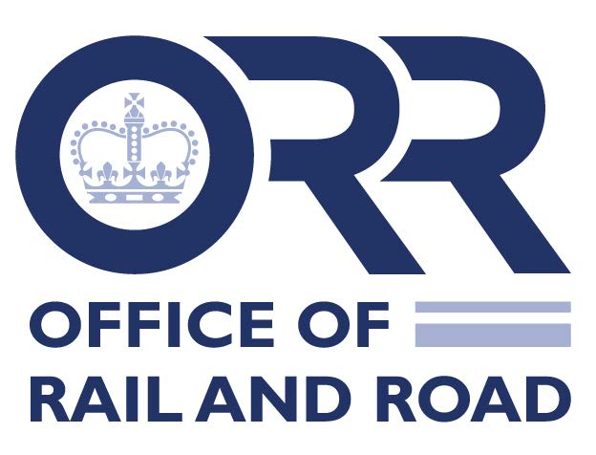
Renewal of Train Driving Licences
The Train Driving Licences and Certificates Regulations (TDLCR) 2010 provide that licences are valid for a maximum of 10 years. Therefore, as a licence expiry date approaches, train operators should read this note and then submit the renewal application form below on behalf of the driver.
The renewal process has been simplified compared to a first licence application. Please complete the form in full, provide the requested information and complete the declarations. You should also supply a new photograph and signature from the driver. Completed application forms and all attachments should be e-mailed to TDL.Applications@orr.gov.uk
There is no limit in respect of how far in advance of expiry a licence can be renewed. We will process complete applications within one calendar month. However, we suggest applying in a timely manner as, in our experience, incomplete applications can affect processing times. A driver must be in possession of their licence at all times when driving a train.
The maximum validity of the licence is 10 years. An early application for renewal will only result in a new 10 year licence. There is no provision to carry over the remaining time from the old licence to the new licence. The new licence will have the same licence number as the old one.
Once the driver has received their new licence, their old licence is no longer valid and must not be used. The old licence should be destroyed by the driver once the new licence has been received.

Train Driving Licence 10 year renewal form
To apply to renew a train driving licence you must complete this form in full. That includes providing all the evidence we request, including details for maintaining medical and psychological fitness and continuous training to ensure ongoing competence requirements.
Please note: Applications for licence renewals can be made at any point in advance of the licence expiry date, but renewed licences will be valid for no more than a 10 year period.

Safety organisation/authority information
- Safety organisation/authority applied to:
Office of Rail and Road

Licence details
- Please confirm that this application is only for a renewal of a current UK train driving licence:
Renewal: yes
UK train driving licence number:

- (Only for renewal of UK train driver licences by cross-border drivers who also hold an EU train driver licence). Please provide your EU-issued train driving licence number:

Application details
- Name of train operator submitting the form on behalf of the driver:

- If the driver has joined your organisation within the last 12 months, please supply their previous employer’s details:

.

- Current train operator’s postal address, telephone number and e-mail:

- Train driver details:

Surname:

First name:
Middle names (if any):

Date of birth (YYYY-MM-DD):

Place of birth:

- New photo and permanent address of the driver (house number, street name, town/city, postcode, mobile number and e-mail).
Driver’s contact details

Driver Photo

See Annex A for specifications

Driver Signature

- Has the driver passed a medical examination carried out by a doctor who appears on the ORR recognised doctor register and within the required periods set out in the TDLCR 2010? Drivers under 55 must pass a TDLCR medical every 3 years and once the driver reaches 55 they are required to pass a TDLCR medical annually:
Yes No
(If no – please contact TDL.Applications@orr.gov.uk prior to submission)
Full name of doctor:

Doctor’s ORR registration number:

Date of examination (YYYY-MM-DD):
Does the driver wear glasses or lenses? Yes No
Does the driver wear hearing or communications aids? Yes No
Declarations
- The train operator confirms that there are no current issues with this driver’s ongoing psychological fitness to continue to drive trains on the mainline.
Yes No
(If no – please contact TDL.Applications@orr.gov.uk prior to submission)
- This driver has completed general competence training and passed the relevant examination carried out by trainers and examiners who appear on the ORR register at their first licence application. The train operator confirms that there are no current issues around this driver’s ongoing competence to drive trains on the mainline.
Yes No
(If no - please contact TDL.Applications@orr.gov.uk prior to submission)
- I declare that all the information provided on this application form and any additional information is true. I understand that my application may be rejected and / or my licence withdrawn if it is subsequently found that I have given false information or withheld relevant details and that the provision of false information in pursuance of a train driving licence is an offence under section 33(1)(k)(ii) of the Health & Safety at Work etc. Act 1974.
Driver signature:

- I declare that all the information provided on this application form and any additional information is true. I understand that the application may be rejected and / or the licence withdrawn if it is subsequently found that false information has been provided. The provision of false information in pursuance of a train driving licence is an offence under section 33(1) (k)(ii) of the Health & Safety at Work etc. Act 1974.
Name of person signing on behalf of

employer

Employer signature:

- ORR is responsible for issuing and regulating train driver licences in accordance with the Train Driving Licences and Certificates Regulation 2010. When processing personal data for train driving licensing purposes, we are relying upon the lawful basis that processing is necessary for compliance with a legal obligation conferred on ORR. Please see ORR’s privacy notice for further information about how we handle personal data.
Name of person signing on behalf of employer:

Job title:

Signature:
Date:

Signature of train driver:

Date:

Checklist for applications for the renewal of a train driving licence, including documents to be appended
- A copy of current licence (please retain current licence until the reissued licence is received)

- A recent (within the last month) photograph of the train driver which conforms to the standards in Annex A

- Check that all questions on this form and the declarations have been fully completed

- Check that all signatures are original and not digital (this is important as the driver’s signature will appear on the licence)

- Send completed applications to TDL.Applications@orr.gov.uk

Annex A
Digital photograph standard required for TDLCR
The photograph should be in the form of a jpeg, bmp or tiff, which enables good definition for small-scale photographs.
The following guidelines should be adhered to:
- The photograph must be of a full face with open eyes
- The photograph must show the full head of the train driver from the top of their hair to their shoulders
- Photograph to be taken against a plain white or off-white background
- Photograph to avoid having shadows on the face or background
- The photograph to show the train driver with a natural expression (e.g. closed mouth)
- The train driver’s face in the photograph should not include sunglasses, sunglasses with coloured lenses or glasses with a thick frame.
- If the train driver normally wears glasses these should be worn in the photograph, no light should be reflected in the glasses.
- The train driver should not wear head wear, unless required for religious or medical purposes
- The contrast and lighting in the photograph should be normal.

