CHP@orr.gov.uk

Office of Rail and Road
25 Cabot Square
London
E14 4QZ
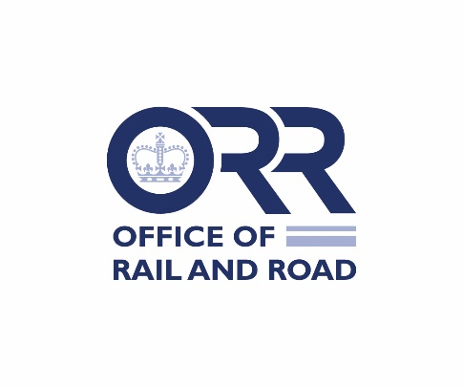
Response letter

Modification of Eurostar International Ltd’s Complaints Handling obligations
On 20 October 2022, the Office of Rail and Road (“ORR”) issued statutory consultations on proposals to modify the licence of Eurostar International Ltd in respect of its obligations regarding Complaints Handling (the “Consultations”).
Please use this form to respond and provide your consent, representations or objections to the respective complaints handling modifications. This form should be returned to ORR using the contact details above by 5pm 21 November 2022.
Please indicate your response by placing a mark in the appropriate box below:
Complaints Handling Obligation | Yes | No
I confirm that Eurostar International Ltd consents to ORR’s proposed modifications to Complaints Handling obligations, as set out in Annex A1 of the Consultations | ☐ | ☐

If you have any objections or representations, please state them here:

Name …………………………………………………

Position …………………………………………………

Date …………………………………………………

For the licence holder
Please return this form to ORR using the contact details above, preferably using email to CHP@orr.gov.uk by 5pm on 21 November 2022.

