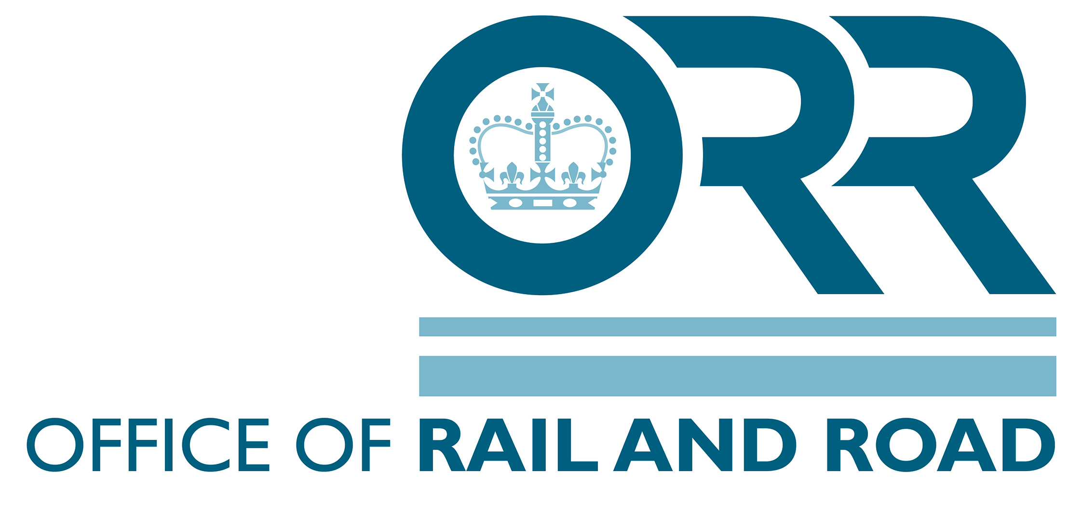
The Railways and Other Guided Transport Systems (Safety) Regulations 2006 (as amended) (ROGS)

Regulation 20

Annual Safety Report Template for 2019

tor

Network Rail Monitor

Network Rail Monitor

Network Rail Monitor

Annual Safety Report Form

Name of Organisation
Type of Organisation (TOC, FOC or NR)

Period covered by report
Date of submission to ORR

Safety Manager contact details

Name
Job Title
Address
Telephone
Fax
Email

Reported Prepared by
Signed off by

Guidance on how to complete this template is available at https://orr.gov.uk/__data/assets/pdf_file/0019/2728/annual-safety-report-guidance-for-mainline-transport-operators.pdf.

When completed, please email completed form to rogs@orr.gov.uk

Section A: Targets which have been set & methods of monitoring progress towards them
ROGS Regulation 20 (1)(a):
Information on how the transport operator’s safety targets, referred to in paragraph 2(b) of Schedule 1, are met

Section A: General Narrative

Table A1: Workforce Safety
Key Risk Area |  | Target Set for 2019 | Commentary on monitoring process and strategy to meet the target.

A1.1

A1.2

A1.3

A1.4

A1.5

Table A2: Passenger Safety
Key Risk Area |  | Target Set for 2019 | Commentary on monitoring process and strategy to meet the target.

A2.1

A2.2

A2.3

A2.4

A2.5

Table A3: Operational Safety
Key Risk Area |  | Target Set for 2019 | Commentary on monitoring process and strategy to meet the target.

A3.1

A3.2

A3.3

A3.4

A3.5

Table A4: Other
Key Risk Area |  | Target Set for 2019 | Commentary on monitoring process and strategy to meet the target.

A4.1

A4.2

A4.3

A4.4

A4.5

Section B: Targets which have been set & outcomes
ROGS Regulation 20 (1)(b)

The results achieved through putting the transport operator’s safety plans, referred to in paragraph 2(b) of Schedule 1, into effect

Section B: General Narrative

Table B1: Workforce Safety
Key Risk Area |  | 2019 Target | 2019 Target Outcome | Commentary on outcome

B1.1

B1.2

B1.3

B1.4

B1.5

Table B2: Passenger Safety
Key Risk Area |  | 2019 Target | 2019 Target Outcome | Commentary on outcome

B2.1

B2.2

B2.3

B2.4

B2.5

Table B3: Operational
Key Risk Area |  | 2019 Target | 2019 Target Outcome | Commentary on outcome

B3.1

B3.2

B3.3

B3.4

B3.5

Table B4: Other
Key Risk Area |  | 2019 Target | 2019 Target Outcome | Commentary on outcome

B4.1

B4.2

B4.3

B4.4

B4.5

Section C: Common Safety Indicators
ROGS Regulation 20 (1) (c):

Statistics for the common safety indicators listed in Annex I of European Directive 2004/49/EC (as amended by Directive 2014/88/EU) insofar as they are relevant to the operation in question

ORR will no longer collect data for the common safety indicators (CSI) using this template. Instead they will be collected separately as part of pre-existing CSI data collection arrangements between transport undertakings and RSSB. For infrastructure managers, these data will be collected by ORR through bilateral communications.

The intention is that these changes reduce the burden on transport operators with regards to data provision.

Section D: Internal Safety Audits
ROGS Regulation 20(1)(d)
The findings of safety auditing carried out pursuant to the procedures referred to in paragraph 2(k) of Schedule 1

Section D: General Narrative
Number of internal safety audits planned for 2019:
Number of internal safety audits completed in 2019:

In the table below, please list significant outcomes and actions taken as a result of internal safety audits.

Table D1: Outcome of Audits
 | Subject of audit | Outcome of Audit/Actions taken as a result of audit i.e. have recommendations been completed
D1.1
D1.2
D1.3
D1.4
D1.5
D1.6
D1.7
D1.8
D1.9
D1.10
D1.11
D1.12
D1.13
D1.14
D1.15

Please mark unused rows as “N/A”

Section E: Major Malfunctions/Deficiencies
ROGS Regulation 20 (1)(e)

Comments on any deficiencies or malfunctions relating to the running of vehicles or the management of infrastructure relating to the operation in question that may be relevant to the safety of that transport system.

Section E: General Narrative

Table E: Major malfunctions/Deficiencies
 | Description of Malfunction/ Deficiency | Actions taken or lessons learned from these events, please provide commentary
E1.1
E1.2
E1.3
E1.4
E1.5
E1.6
E1.7
E1.8
E1.9
E1.10

Section F: Experience of applying the common safety method for risk evaluation and assessment
Commission Implementing Regulation (EU) 402/2013 (Article 18) - Experience with the application of the CSM for risk evaluation and assessment. The report shall also include a synthesis of the decisions related to the level of significance of the changes.

Please enter details below

Section G: Experience of applying the common safety method for monitoring
Commission Regulation (EU) 1078/2012 (Article 5) - Experience with the application of the CSM for monitoring.

Please enter details below

Guidance on how to complete this template is available at https://orr.gov.uk/__data/assets/pdf_file/0019/2728/annual-safety-report-guidance-for-mainline-transport-operators.pdf.
.
When completed, please email completed form to rogs@orr.gov.uk

