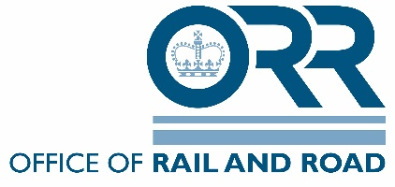

Train Driving Licences & Certificates Regulations 2010
Application form for entry on to ORR’s register of recognised persons - DOCTORS

Registration with the General Medical Council as medical practitioner & business address
- Please provide full name and GMC registration number
- Address that will be used for any medical assessments
Evidence of 2 years’ experience in occupational medicine
- May be provided with reference to CV
Evidence of recognised qualification in occupational medicine (e.g. either as an Associate, Member or Fellow of the Faculty of Occupational Medicine. Or, by holding either a Diploma, Advanced Diploma or MSc in Occupational Medicine)
Evidence of meeting the requirements in the ARIOPS competency guidance for a registered medical practitioner

Evidence of knowledge of the type work carried out in the railway environment
- May be demonstrated through visits to the operational railway to gain an understanding of working on the railway
Evidence of working to the required legal standard
May be demonstrated through a declaration that the applicant is;
- Working to the requirements set out in Schedule 1 of the TDLCR 2010 for medical assessments and RIS-3451-TOM Issue 1; or
- Working to the requirements set out in Annex II of the EU Directive 2007/59/EC on the Certification of train drivers operating locomotives and trains on the railway system in the Community; or
- Working to another recognised equivalent. Please provide details.

General Data Protection Regulation (GDPR) and Data Protection Act 2018
We respect your right to privacy. The Office of Rail and Road (ORR) has in place a privacy notice which details how we processes personal data that we collect from and about you and how we may use your information in accordance with the General Data Protection Regulation (GDPR) and Data Protection Act 2018. Our full privacy notice can be found on our website ORR.Gov. UK
ORR must also have, and keep up to date, a register of recognised professionals, namely doctors, examiners, psychologists and trainers. For the process of assessing and maintaining this register, we will process the following information:
- Your name;
- Your contact details;
- Your e-mail address
- Employment/profession details;
- Qualifications;
- Details in relation to your independence, competence.

If you do not provide this information and consent to its usage by ORR for providing and maintaining registers of Medical Practioners then ORR would not be able to process your application for a train driving licence or to become a recognised professional.
If you wish to withdraw your information at any time, please contact us to remove your details from our register.

